Tracks along the Trail
Glacier National Park
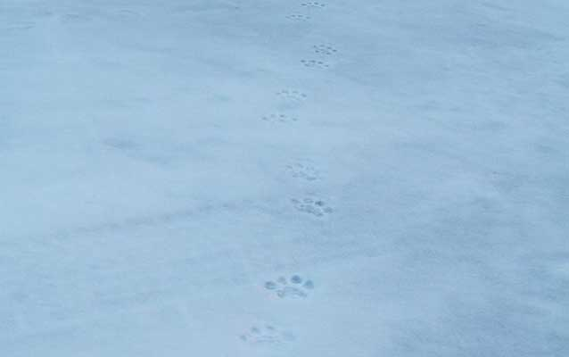
Mountain lion tracks in snow. NPS Photo

GRADE LEVEL:
Third Grade-Fifth Grade
GROUP SIZE:
Up to 24
SETTING:
classroom
NATIONAL/STATE STANDARDS:
MT Common Core Standard 4.OA.5:
Generate and analyze patterns: Generate a number or shape pattern that follows a given rule. Identify apparent features of the pattern that were not explicit in the rule itself.
KEYWORDS:
tracks, tracking, wildlife sign, winter

Overview
Students identify patterns from their own tracks and then look at those made by animals. They make “track cards” to use for matching, classifying, sorting, and a variety of activities.

Objective(s)
Students will identify shapes and patterns of different animal tracks.

Background
As you travel outside through the forests and neighborhoods, snow becomes like pages in a book. Stories are revealed by tracks, trails and impressions in the snow. These are winter signs. If you are lucky enough to see wildlife while on your travels, please remember to keep your distance. Any extra effort an animal puts out in order to "escape" from you could mean the difference between life and death. Snow is a great writing board for stories about animals. Wildlife viewing is often a matter of luck or being in the right place at the right time. Tracks, whether fresh or a few days old, are evidence of wildlife presence; and the tracks reveal much about the private lives and habits of the animals that made them. Scientists use tracks to learn about wildlife routines. Some of the tracks that may be found on a winter outing in Glacier National Park are shown on the Track Maker Copy Page. Tracks can be difficult to identify at times, depending upon snow type, how old they are and temperature/snow conditions since the tracks were made. Also other types of wildlife signs may be left by wildlife including: scat, beds, chewed twig ends, gnawed-on bark, animal lodges and bank dens, hair, feathers, blood, and urine markings. Learn more about Track Makers and animal sign in Glacier.
Materials
In the Snow: Who's Been Here?
Track Maker Copy Pages
Animal Cards Copy Pages
Index cards
Scissors
Glue
Other materials dependent on extension activities
Procedure
- Start with a discussion of what a "track" is and how it can tell a story. Read the story book In the Snow: Who's Been Here? Discuss how snow is like a magic powder, revealing signs and tracks that couldn't be seen before the snowfall. Students may relate to this by noticing how their dogs sniff the round at what looks invisible before the snowfall, but after a snowfall, can see that where the dog has been sniffing has lots of squirrel tracks or deer tracks, or maybe the neighbor's cat's footprints! Maybe they can see footprints in their driveway and realize that the newspaper carrier walked that way.
- For younger students, you can have them trace and make copies of their own feet or solebutcher paper "rubbings" of the bottoms of their shoes. Cut out the tracings and label one side. Then mix up the tracks and see if students can identify whose tracks are whose! Go outside with pairs of students and have one partner hide their eyes while the other tries to make tracks in the schoolyard. See if their partner can follow the correct tracks to find them!
- It's important to recognize tracks in order to know what wildlife is present and what areas and habitats different animals are using. A number of concepts and activities can be done to teach students about how tracks tell us about wildlife by creating "tracks cards." Make photocopies of the "Animal Cards" and "Track Maker Copy Pages" for each student. Have students cut out each track and glue it to one side of an index card or a colored piece of paper. On the other side of the card, they can glue the information about that animal (and maybe even a picture from the animal drawings section). A variation would be to put the animal information and/or picture on a separate card. Half of the students can each be given the track picture, and half get the animal information cards. Then they have to find the person with their "match."

Assessment
Students successfully complete one of the extension activities.

Extensions
- Math: See if students can find patterns in the tracks - which animals have 2 toes? 3 toes? 4 toes? 5 toes? Now read the information about the animals, are the ones with the same number of toes related? (ungulates=2; birds = 3; weasels=5, etc...). Use the tracking field guide books to find more animals with the same number of toes. Measure the stride (distance between two tracks made by the teacher). Does the stride change as the animals starts running? Try this with your own stride.
- Math: Have students use graph paper and information on scale drawings to proportionally double the size of the tracks that are shown at 1/2 their actual size. Discuss how size relates to winter survival. Animals with big feet (lynx, snowshoe hare) can walk on top of the snow.
- Art & Science & Math (shapes): Explain that an animal's track is unique and can reveal a lot about where it lives and what it does for a living. For example, the webbed hind feet of the beaver are adapted for swimming while the large furry hind feet of the snowshoe hare are for travelling on top of deep snow. Tracks in the snow are often the best way to determine that winter animal activity is taking place in an area. Becoming a skilled "tracker" takes patience and a lot of time out in the snow observing. Each animals' track is different in shape, size, and design (depending on its function -see the background information section or field guide book). Having students study the tracks on the "Track Maker Copy Page" and thenuse their imagination to create animals, designs, or even snowflakes will help them internalize track shapes and remember some of the functional reasons for those shapes (see sample page of "Track Art").
- Language Arts & Science: Have the students make "A day in the life of ______" track story. They need to trace and cut out multiple track copies of two of the animals that would be considered predator and prey (ie. pine marten and red squirrel; Lynx and snowshoe hare; coyote or mountain lion and deer or elk, etc...) and research and think through what those animals might do in one day. They should write their story first and then illustrate it with tracks on a large piece of butcher paper. They can show the predator chasing its prey and perhaps the prey goes into a hole or up a tree. Students then present their story to the class, or see if the class can "read" what happened in their story. Alternatively, stories can be made on window shades and rolled open as the story progresses. Sponge stamps or stencils can be used instead of paper cut-outs of tracks.
- Science: A variation on the track cards could be made in order to play "Track Jeopardy" with the categories being the number of toes in the track and the clues being the animal information cards.
- Physical Education: Make a "Track Twister" game by using fabric paint on an old sheet with big squares with each of the different tracks. Make a spinner that tells the caller what track to call out and what part of the body each student has to reach over and touch that track with (hand, elbow, foot, nose, etc...). This could require some real acrobatics to make a ring
- Go outside and look for tracks! Keep a journal of tracks that you see and draw a map of them. Find patterns in the animal's movements over time, are they going back to the same tree? Do they follow the same trail? How often do the same tracks appear?
- Learn track patterns - explain to students that animals walk in four basic track patterns (the repeating design their footprints make in the snow). Make a single large oval on eight 3x5 index cards. Cut four of the 3x5 cards in half and make a single small circle on each of them. (A total of 16 track pattern cards). Use these cards to demonstrate the four basic track patterns on the next page. Lay them on the floor to imitate the different patterns. You can name the animal or pattern type and then see if the students can lay down the cards correctly or once the cards are laid down, ask a volunteer if they can try to walk in this pattern with feet on the first two prints, and hands on the next two.

